*ACC Biology 1408*

*Biology for Non-Science Majors*

*Mrs. Lherisson*

*Study Guide*

*EXAM 1*

**Core Topic #1:** The Nature and Methods of Science

**Chapter 1, 1.1-1.14**

1. The organism pictured on the front of the textbook is called a red panda. What four adaptations of this animal does the author describe, and how do they each help the panda survive?
2. In your own words, describe what it means to be alive. How does your definition align with that of the textbook?
3. Describe each of the three domains of life, including the name, defining characteristics, and examples. How do these domains relate to the levels of taxonomy?
4. What levels of organization are studied in biology? How does the concept of emergent properties fit into this hierarchy of organization?
5. What is the scientific method? Be sure that your discussion correctly uses all of the following vocabulary terms: data, hypothesis, experiment, theory, independent variable, dependent variable, controlled experiment, observational data, clinical trials, repetition, nonlinear, collaboration, and societal benefits. Bold or underline each vocabulary term as it is used in your answer.
6. What effect has technology had on the study of biology?
7. Discuss in detail each of the five unifying themes of biology.

*EXAM 1 (continued)*

**Core Topic #2:** Cells: Characteristics of Life; Basic Cell Components; Types of Cells; Hierarchy of Life

**Chapter 4, 4.1-4.22**

1. Discuss the different type of microscopes, and their ability to magnify cells.
2. Explain why most cells are small.
3. What makes a prokaryotic cell different from a eukaryotic cell? Use the chart to compare these two very different types of cells.

|  |  |  |
| --- | --- | --- |
| Eukaryote | Both | Prokaryote |
|  |  |  |

1. What is cellular metabolism?
2. For each of the organelles listed in your textbook, describe the location, structure, function, and in what types of cells they are found.

**Chapter 5, 5.1-5.9**

1. Describe the structure of the plasma membrane. Discuss **in detail** how this structure is involved in the various methods of transporting materials into and out of the cell. Be sure to tell whether energy is necessary to make each type of movement possible. (Hint: Include a diagram of the structure, as well as a paragraph description.)

*EXAM 1 (continued)*

**Core Topic #3:**Evolution and its Mechanisms:  Natural Selection, Recombination, and Mutations

**Chapter 13, 13.1-13.8**

1. Explain the relationship between natural selection and the development of adaptations in organisms.
2. In science, a theory is different from a hypothesis.  Explain how these are different.
3. Describe Darwin’s theory of evolution by natural selection.  What fossil evidence supports the theory of evolution?
4. What are homologous structures?  Explain how they provide evidence of a common ancestor.  How does this concept relate to vestigial structures?
5. What impact have the advances in molecular biology had on our understanding of relationships between organisms?

1. Explain what an evolutionary tree is, and how it can be used by evolutionary biologists.
2. What is artificial selection, and how is this concept different from natural selection?
3. What role do mutations and sexual reproduction play in evolution?
4. Can evolution occur in an individual organism?  Give evidence to back up your answer.

*EXAM 2*

**Core Topic #4:** Chemistry of Life: Important Inorganic Substances and Biomolecules

**Chapter 2, 2.1-2.16**

1. What are trace elements, and why are they important?
2. What are three types of bonds, and how are they formed?
3. What is the purpose of chemical reactions that happen in the body?
4. What properties of water make it vital to life on our planet?

**Chapter 3, 3.1-3.16**

1. What is an organic compound?
2. Describe the chemical groups which are key to the functioning of biological molecules.
3. What are dehydration synthesis and hydrolysis, and why is each important?
4. Describe each of the four biomolecules of life, including its name, monomer, polymer, examples, structure, purpose, elements, and unique properties.

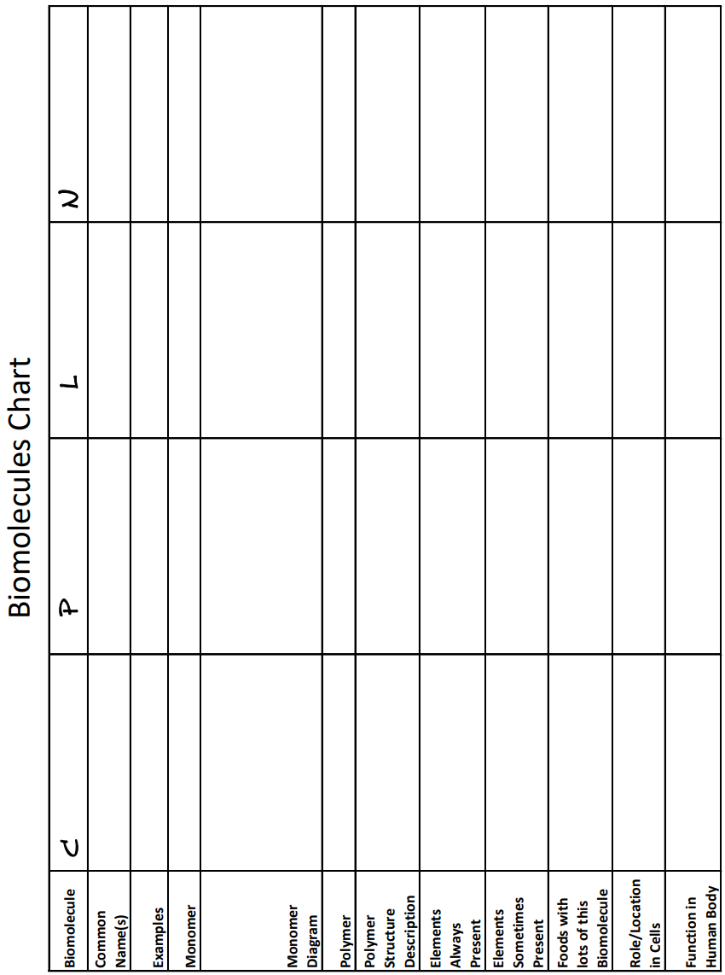

*EXAM 2 (continued)*

**Core Topic #5:** Cell metabolism: Photosynthesis and Respiration

**Chapter 5, 5.10-5.16**

1. What is the first law of thermodynamics, and how does this relate to the energy of a cell?
2. How does the structure of ATP allow it to store energy for later use by a cell? (Hint: Draw or include a diagram.)
3. Describe the structure of an enzyme, as well as its role in cellular metabolism. Be sure to use the words: activation energy, substrate, active site, catalyst, and chemical reactions. (Hint: Draw or include a diagram.)

**Chapter 6, 6.1-6.15**

1. What do we mean by the term “aerobic” when we say aerobic cellular respiration?
2. Describe all of the stages of cellular respiration. Be sure to mention the purpose of oxygen in this process. Be sure to include the vocabulary terms: glycolysis, pyruvate oxidation, the citric acid cycle, NAD+, NADH, electron transport chain, oxidative phosphorylation, and chemiosmosis. (Hint: Draw or include a diagram.)
3. What is fermentation, and how is it related to cellular respiration?

**Chapter 7, 7.1-7.14**

1. Describe the stages of the light dependent reactions, also called the light reactions, of photosynthesis. Where is the energy stored at the end of this part of the process of photosynthesis? What is the purpose of water in this process? Be sure to include the vocabulary terms: chloroplast, thylakoid, photon, photosynthetic pigment, chlorophyll, photosystem I, electron transport chain, photosystem II, ADP, ATP, ATP synthase, NADP+, and NADPH. (Hint: Draw or include a diagram.)
2. Describe the stages of the Calvin Cycle, also sometimes called the light independent reactions, of photosynthesis. Where is the energy stored at the end of this part of the process of photosynthesis? What is the purpose of in this process? Be sure to include the vocabulary terms: ADP, ATP, NADP+, and NADPH, carbon fixation, and glucose. (Hint: Draw or include a diagram.)

*EXAM 3 (continued)*

**Core Topic #6:** Protein synthesis: DNA structure, Transcription, and Translation

**Chapter 10, 10.2-10.3; 10.6-10.15**

1. How does the structure of a nucleotide contribute to the structure of a polynucleotide? What parts of the nucleotide form the sugar-phosphate backbone? (Hint: Draw or include a diagram.)
2. What is the difference between purines and pyrimidines, and which bases belong to each group.
3. What is the structural difference between DNA and RNA?
4. What are the base pair rules and how did this influence Chargaff’s rule? What is the role of hydrogen bonding in this rule, and in the double helix shape of DNA?
5. What is a codon? How is it formed? What is its purpose? What is an anticodon, and how is it related to a codon?
6. What role does RNA play in protein synthesis?
7. Together, transcription and translation make up protein synthesis. Create a chart or diagram to show the purpose, location, steps, and product of both transcription and translation. (Hint: This answer should be very specific, and include all of the steps.)

*EXAM 3 (continued)*

**Core Topic #7:** The Cell Cycle: DNA Replication; Mitosis; Cytokinesis; Bacterial Fission

**Chapter 8, 8.1-8.8**

1. Compare asexual and sexual reproduction as they relate to cell division.

1. Describe the process of binary fission, including what type of organisms it relates to and what steps take place.
2. What are the four basic steps of the cell cycle, and what happens during each step? (Hint: Draw or include a diagram.)
3. What is cytokinesis, and how does this relate to mitosis, the cell cycle, and cell division?
4. What are the five steps of mitosis, and what happens during each step? (Hint: Draw or include a diagram.)
5. What are checkpoints, and how do these protect against problems during cell division?

**Chapter 10, 10.4-10.5**

1. Describe in detail the process, purpose, location, and timing of DNA Replication.

*EXAM 3 (continued)*

**Core Topic #8:** Mutations: Causes and Effects; Somatic vs Germ-line Mutations

**Chapter 8, 8.9-8.10**

1. How is the cell cycle related to cancer?
2. What is a tumor, and what are the two types of tumor?
3. What is metastasis?

**Chapter 10, 10.16; 10.22-10.23**

1. What is a mutation? Discuss the different types of mutations.
2. What is a mutagen, and how is it related to mutation?
3. Discuss each of the three ways that bacteria can transfer DNA among themselves.
4. What is a plasmid, and how does this relate to bacterial DNA transfer?

**Chapter 11, 11.15-11.18**

1. What is cancer, and how does it relate to mutation?
2. Describe the progression of a cell from a normal somatic cell to a cancerous cell.
3. How can changes in lifestyle reduce the risk of cancer?

*EXAM 4*

**Core Topic #9:** Patterns of inheritance: Meiosis; Mendelian and Molecular genetics; Hereditary Disease

**Chapter 8, 8.11-8.23**

1. What is meiosis? Describe the stages and tell what the end result will be. (Hint: Draw or include a diagram.)
2. Compare meiosis to mitosis, using a chart or Venn diagram.
3. Define homologous chromosomes, and describe two processes involving homologous chromosomes that increase genetic diversity in the resulting gametes.
4. What is a karyotype, and how do geneticists use this tool to learn about genetic disorders?

**Chapter 9, 9.1-9.23**

1. Why is Mendel considered to be the father of genetics? (Hint: Your discussion must include pea plants!)
2. Compare monohybrid crosses with dihybrid crosses.
3. What is the law of independent assortment?
4. What is a testcross, and how can this be used to determine the genetic makeup of an organism?
5. What are pedigrees and how are they used to track genetic traits?
6. How did the behavior of chromosomes lead to Mendel’s laws?
7. What are sex linked genes?

*EXAM 4 (continued)*

**Core Topic #10:** Biotechnology: Basic Methods and Representative Practices

**Chapter 11, 11.12-11.14**

1. What does it mean for a cell to be totipotent?
2. What is cloning, and how can nuclear transplantation be used to clone organisms?
3. How is therapeutic cloning different from reproductive cloning?
4. What are stem cells, and how are embryonic stem cells and adult stem cells different?

**Chapter 10, 10.22-10.23**

1. What are plasmids, and why are they causing a problem for humans?

**Chapter 12, 12.1-12.21**

1. Describe the process of inserting recombinant plasmids into bacteria (see both 12.1 and figure 12.1B.) Give examples of how this process can benefit humans (12.6 and 12.7.)
2. What is CRISPR-Cas9, how does it work, and why is this tool so important?
3. In what ways is genetics changing the field of agriculture? How has this become a bioethics discussion?
4. What is gene therapy, and why is this important?
5. How has the study of genetics impacted criminal investigations? What does this have to do with DNA profiling, PCR, and gel electrophoresis?
6. What is genomics, and why is this field of study so important (12.17-12.21)?

*EXAM 4 (continued)*

**Core Topic #11:** Viruses: Basic Virus Structure; Viral Replication

**Chapter 10, 10.1; 10.17-10.21**

1. What was the significance of the Disneyland Measles outbreak in 2014?
2. Describe the structure of a bacteriophage. (Hint: Draw or include a diagram.)
3. Compare the lysogenic and lytic cycles of bacteriophage virus replication. (Hint: Draw or include a diagram.)
4. How does the lytic cycle of a bacteriophage compare to the replication cycle of an enveloped virus?
5. What are emerging viruses and where do they come from?
6. How is the HIV virus different from other viruses?
7. What is a prion, and how does it compare to the structure of a virus?